# DAY 6: EVENING ASSESSMENT

1. Write a Python program to create a file and write multiple lines into it.

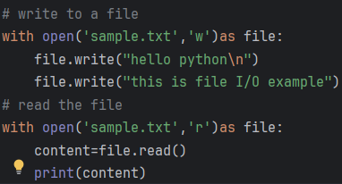

1. Write a program to read the first n lines of a file.

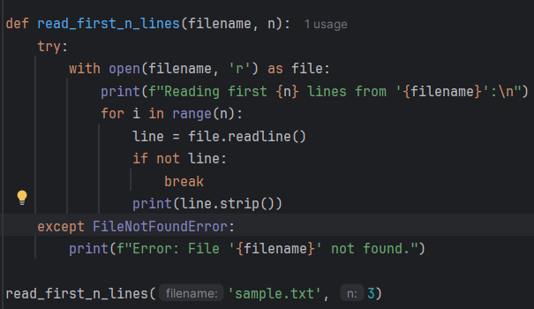

Reading first 3 lines from 'sample.txt':

hello python

this is file I/O exampleThis is an appended line.

1. Write a program to append content to an existing file without overwriting it.

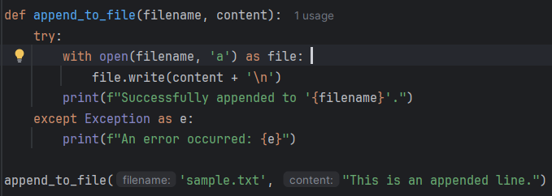output: Successfully appended to 'sample.txt'.

1. How do you check whether a file exists using the os module?

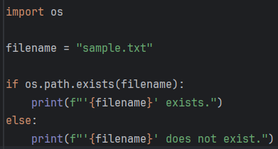

Output: 'sample.txt' exists.

1. Write a program to copy the contents of one file into another file.

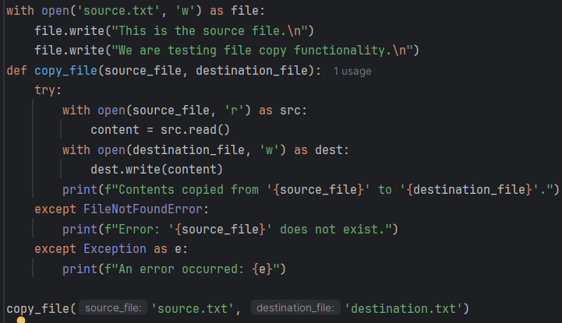

Output: Contents copied from 'source.txt' to 'destination.txt'.

1. Write a Python script to read a file and count:  
    - Total lines  
    - Total words  
    - Total characters

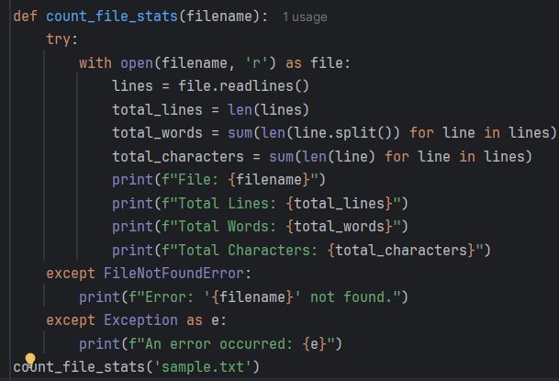

File: sample.txt, Total Lines: 2, Total Words: 11, Total Characters: 63

1. Write a program to merge the contents of two text files into a third file.

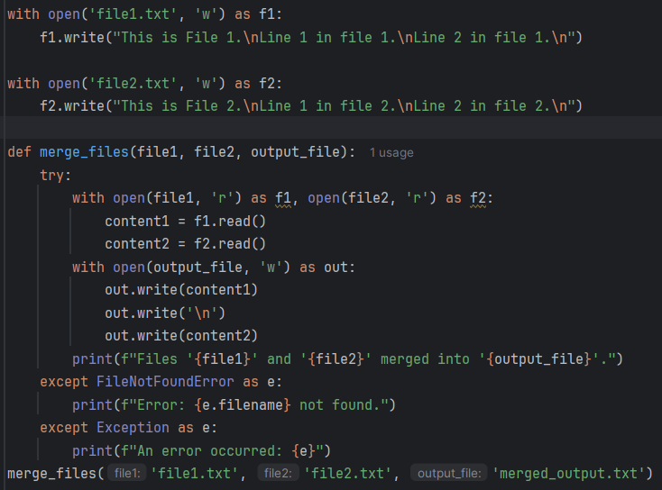

Output: Files 'file1.txt' and 'file2.txt' merged into 'merged_output.txt'.

1. Write a Python program to read a file and display only unique lines (remove duplicates).

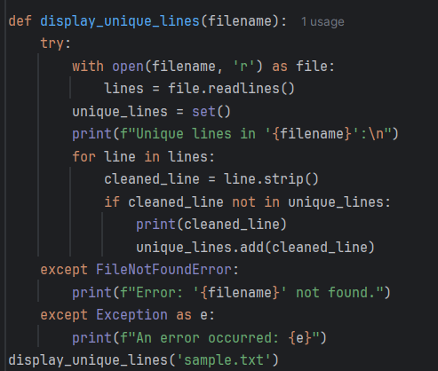

Output: Unique lines in 'sample.txt':

hello python

this is file I/O exampleThis is an appended line.

1. Write a program that reads a file and prints only the lines that contain a specific keyword.

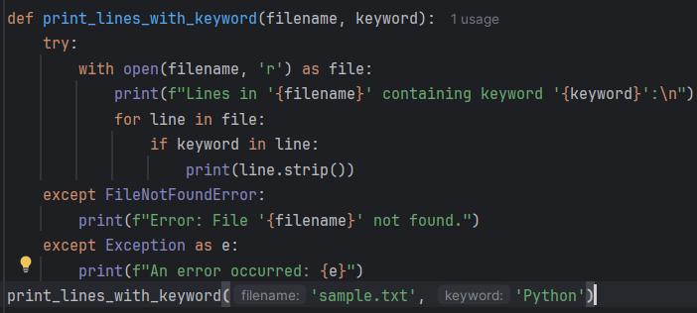

Output: Lines in 'sample.txt' containing keyword 'Python':huuu

1. Write a program to read the last n lines of a file.

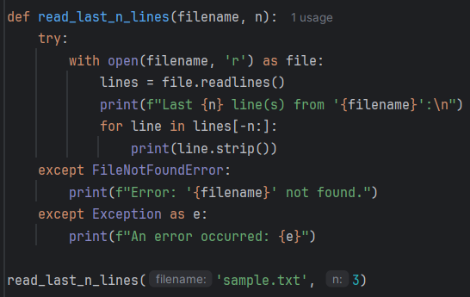

Output:  
Last 3 line(s) from 'sample.txt':

hello python

this is file I/O exampleThis is an appended line.

1. Write a program to count the frequency of each word in a file.

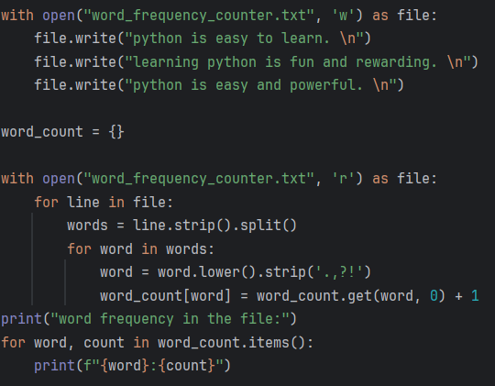

Outputword frequency in the file:

python:3

is:3

easy:2

to:1

learn:1

learning:1

fun:1

and:2

rewarding:1

powerful:1

1. Write a program to write a list of strings into a file, each string on a new line.

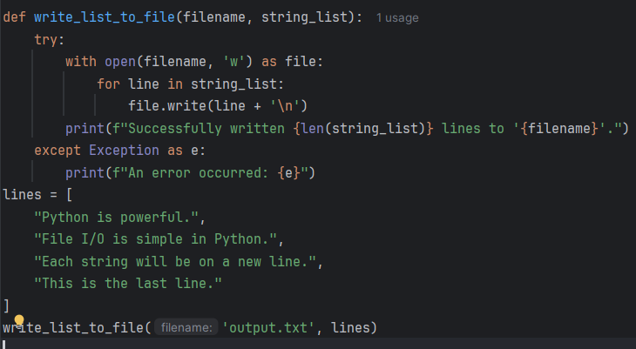

Output: Successfully written 4 lines to 'output.txt'.